

###### **www.phoenixbrassband.co.uk**

###### The War Memorial Hall,

###### Froxfield,

###### WILTS.

# Phoenix Brass

***President :* Michael Kilroy**

***Honorary Vice Presidents:***

**Mrs Christine Peacock**

**Cdre A.J.G Miller CBE RN**

**Lt Cdre Mark Sheldon RN**

#### **Banding Enquiry and Engagement Booking Form**

Please complete and sign this Engagement Booking Form and submit to the Secretary at the address below or email it to the address shown. If you would like to discuss your engagement prior to completing this form, please call the Secretary who will be pleased to assist you.

The fee for Phoenix Brass depends on the size of the Band required, when and how long you want us to play for. It is usual for the Band to play for not less than 45 minutes at a time, with a minimum 20-minute break in between sets with refreshments for the Band.

The band is an autonomous organisation and is completely self-financing since it receives no sponsorship. Both locally and further afield we uphold an enviable popular reputation.

When you are thinking about booking the Band and before completing the form please refer to the Website Page or the notes attached below.

**Engagement Details**

Name of Organisation:……………………………………………………………………………………….

Description of Event:…………………………………………………………………………………………

…………………………………………………………………………………………………………………

………………………………………………………………………………………………………………….

………………………………………………………………………………………………………………….

Contact Name and Address:……………………………………………………………………..…….........

……………………………….………………………………………………………………………………..

Contact Telephone Numbers (landline and mobile)………………………………………………………

Contact Email Address:…………………………………..………………………………………………….

Other Information (if applicable):…………………………………………….……………………...........

…………………………………………………………………………………………………………………..

………………………………………………………………………………………………………………….

Date Required:……………………………………………………………………………..………………

Performing Venue Details (including name, address, post code and directions etc:

………………………………………:…….……………………………………………………………………

………………………………………………………………………………………………………………….

Timing(s):…………………………………………Cost agreed (if known)…………………………….

Signed:………………………………Position in Organisation:………………………………………..

**The Band always appreciates prompt payment of its fees, which is usually at the event, unless otherwise arranged by prior agreement**.

**Practical Matters to Consider When Booking Phoenix Brass**

### What do you want the Band to do?

* It’s best to have a clear idea of what you want the band to do
* What is the event – date, times, location?
* Do you want a full concert?
* Will you want the Conductor to speak to an audience in between pieces, or is the Band providing background music?
* If you require specific musical pieces played, eg hymns, please think about what these are. We may not have the specific items in our extensive library
* Will there be a formal audience for the band, in which case the Band may want to prepare a programme
* Is the band accompanying singing or other activities? In which case greater detail and liaison will be required
* Are additional groups (musical or other) also taking part in the same event? How will the time be shared?
* How long do you want the band to play for and with what intervals?

### What to provide

* For all events the Band will require seating, usually around 30 chairs without arms)
* Light refreshments are always welcome, particularly at intervals, as playing is thirsty work! If you would like to provide the Band with more substantial refreshments, please do so at the end
* The band formation used is shown below.

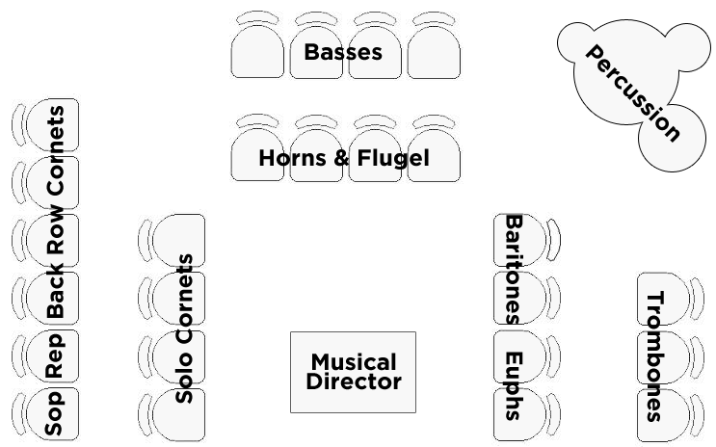

**Band Layout**

* The Band would ideally expect to occupy a space of around 5m x 8m, though smaller spaces could be accommodated. We can play on some stages, but this is dependent entirely on the size and location of the staging. This must be discussed and agreed with the Band in advance
* Will there be a long way to carry equipment, or can the venue be accessed easily?
* Is the venue at ground level, or is it on a higher floor, in which case is there a lift available?
* The Band will need somewhere to store the instrument cases
* It is useful to inform the Band how they will access the venue
* The Band will usually arrive by private cars (many car share) and will need somewhere to park. Instructions where to park will be useful. Close vehicular access to the venue for the Band’s larger instruments and equipment would be appreciated. Car parking close to the venue will be required to securely store instrument cases and personal belongings if other storage facilities are unavailable
* Access to unload the Band van for larger instruments and percussion will often be required

### Outdoor engagements

* Whilst the outdoors is a good place for a brass band in the summer attention should be given to the location
* Drums and percussion instruments are particularly vulnerable to heat and rain, so a shady spot or under cover of a marquee or similar is preferable
* It is useful if the playing area can have some shelter from wind. Music stands carrying music are particularly difficult to deal with in breezy conditions, so any shelter is always appreciated. The Band will bring their own pegs to hold the music on the stands
* In the case of wet or inclement weather, what will the arrangements be? Will the event be cancelled, or moved indoors? Will a marquee or similar to accommodate the Band be provided, noting the playing area requirements above? Will the band still be required? If the Band’s services are cancelled, what notice would we receive, and would there still be payment available?
* From a practical point of view, the ground needs to be relatively flat and/or hard standing. If you want the band to play on grass, please bear in mind that chairs on soft ground quite easily sink into the turf. For safety, we should not be placed next to a busy road. Think also of animals, some of which can be startled by a band if they are not used to them

### Timing

* We often take bookings up to a year in advance, occasionally longer, so please book early. It is best to give as much notice as possible, particularly for booking the Band in the summer months or around Christmas. The Band always considers bookings at any time of the year. At minimum please give several weeks’ notice. The Band is busy throughout the year with a wide range of different engagements and performances
* Once at the venue, the Band will require time to set up, at least three quarters of an hour prior to the playing time, possibly longer in certain circumstances. If there is a shared arena, then details will need to be resolved of how and when the interchange between performances will take place
* The Band prefers engagements that have a reasonable length of playing required. An event that only demands, say, 20 minutes of music or so is not ideal. An hour or two is more usual and ensures that you get the best value from the Band. A typical format concert would be 45 minutes playing in each half, with a 15/20-minute break in between performances

### Payment

* You will not have to pay professional rates for the services of Phoenix Brass; however, our performances are always carried out in a professional manner. We provide excellent value for money, a high standard musical performance for a reasonable fee. An appropriate fee will be quoted to you once we know in outline what the engagement entails
* It does cost a lot of money to run the Band, including music, insurance, uniforms, rehearsal facilities and of course instruments, which cost well in excess of £1,000 each. All band players are volunteers and do not receive payment and money generated from performances is invested back into the Band. Currently, funds are being used to purchase instruments and music